ADMa
LA-SHOP data warehousing – tutor notes and suggested soln based on the tutorials in week 6

Familiarisation with the scenario – a number of shops across different continents, with a computer system working across them all. Most likely this scenario is one centrally located database system, all sites looked at through ‘nodes’.

What are the Business objectives/drivers ?
Increase profit
Improve customer satisfaction
Get more customers
Streamline processes
Provide a better experience than competitors
Family orientated
Increase footfall
Become well known brand
Provide Quality* service
Up their Market share
* Note high level managers make these decisions
* Note you could research this for similar Industries (eg the case study!)
* These are too many – but they are all valid suggestions

Reports to support / evaluate the objectives
Per year profit and loss, compare profit margins compare year on year.
No of customer bookings per shop per year
Weekly sales per region, per shop
- Footfall for individual dept (could we get this?)
- Competitor similar industry similar reports (buy in this info?)
- Staff turnover … what would we use this for? Employee satisfaction?
Spending demographics for the area
Customer trends – what is this maybe? – sales by store by dept by year
External data: Same info for other stores
What depts. are in other shopping malls
Disposable income per person

In order to achieve the objectives eg Increase profit the company will look for ways to improve eg:
Business Suggestions/Ideas
Open new shops
Close shops
Reduce no of complaints
Improve bookings/ profit at a specific shop or over the Company
Reduce the number of complaints a specific shop or over the Company
Introduce a child-care scheme, courses, new facilities
Reduce the number of staff at a specific shop or over the Company
Etc ….

Again what reports could support these business ideas

View revenue per month per shop
View revenue for June per year (ie this year, last etc)
View revenue per month per shop for shops with hairdressing
No of new customers per month based on loyalty cards or similar – no who leave.
Comparison against sales per shop also for facilities
Number of shops in each region of each country
Which customers are booking ‘return’ facilities, how many times have they been in the past year,
Do specific facilities improve the revenue.
Which shops are making the most profit,
Which are our best shops and worst shops (judged by … ?)
How many ‘private’ facilities are there at each shop – are these more cost effect than those that need to be managed.
Etc …

- some of these reports are likely to be run every now and again, some maybe run daily, monthly, yearly. How would they be run – overnight ? as and when real time (ie go in and run them). Will they slow down the system ? does it matter if they do ?

The important part is what data/ attributes/ information do we need and where can we get it from?

Now consider the database requirements/configuration
On a OLTP system, these reports are generated using SQL (report builder or similar).
Eg
SELECT COUNT(crèche_booking_id), shop_name, country
FROM booking, shop, country
WHERE pks to fks
GROUP BY country
(or similar !)

Example Output
For June, 2007
Shop | Country | Region | Revenue | no_creche_bookings
Puerto Blanco | Spain | Basque | 3000 | 200
Torremolinos | Spain | Catalonia | 4000 | 210
Tres Bonne | France | Loire Valley | 2500 | 190
Plata Dorada | Portugal | Algarve | 2000 | 200

If reports are taking a while to run, we could decide to implement a ‘denormalised’ table or view for our most current reports.
Note this example: For June 2007, what if we now want to see July 2007 ?
Related to - Drill up, drill down, aggregates.
Issues: How is this updated ?, how is it maintained ? how long do we keep the data, what is we what slightly different reports ?

One step further and we can implement a DW.

Star schema.

FACT table in the middle (for the above example) ‘FACT’s in bold. (some books call these ‘measures’

time_key
shop_key
country_key
region_key
total_revenue
no_creche_bookings

All star schemas have a time dimension (for the above example).
time
time_key
month_no
year

And other dimension tables
shop
shop_key
shop_name
shop_address

Country
country_key
country_name

Region
region_key
region_name

Final Star- schema
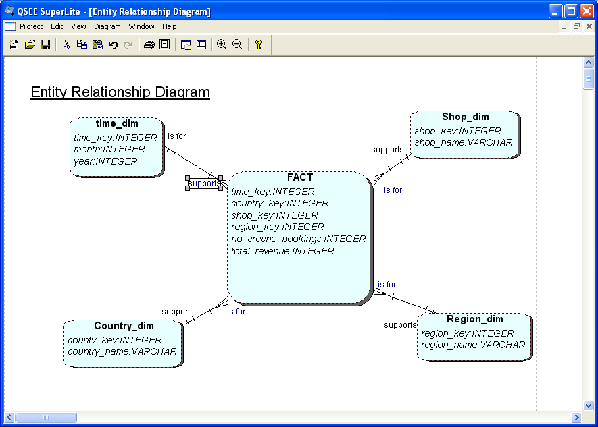

Consider discuss.
Data in a DW is never updated. (what if a shop changes its name, supplier changes address)
What level of granularity do we hold the data.
PK/FK on the FACT table
The use of Nulls
Data marts – are small subject specific star schemas many of which will be held in a data warehouse.

